 Vaccination Information Checkup Information

MISSION:

Wisdom Pet Medicine strives to blend the best in traditional and alternative medicine in the diagnosis and treatment of companion animals including dogs, cats, birds, reptiles, rodents, and fish. We apply the wisdom garnered in the centuries old tradition of veterinary medicine, to find the safest and most effective treatments and cures, while always maintaining a caring relationship with our patients and their guardians.

TESTIMONIALS:

#1: During the summer, my German Shorthair Pointer, Tonto, began to have severe redness and itching on his belly and feet. Through diagnostic testing, we learned that Tonto is severely allergic to over a dozens kinds of grass pollens. We’ve now been doing allergy injections for several months, and his itching and redness have nearly gone away. I’m very thankful to the veterinarians and staff at Wisdom for the excellent care Tonto received, and for nipping his allergies in the bud, so to speak.

#2: When Samantha, our Siamese cat, began sleeping all the time and urinating excessively, we brought her to see the specialists at Wisdom. After running a blood test, Dr. Winthrop confirmed what we all feared - Samantha was showing signs of diabetes. The doctor put us on a daily routine to provide Samantha insulin injections, and showed us how to administer the shots. We weren't sure we could do it, but the gang at Wisdom was very supportive and encouraging. Now, two years later, Samantha is still free from any complications of diabetes, and her blood sugar regularly tests normal. Thank you, Wisdom Pet Medicine!

#3: The staff at Wisdom worked tirelessly to determine why our three-year old Labrador Retriever, Roxie, started going into sudden kidney failure. They stabilized her and provided fluids until her kidneys were again functioning normal, but it was still a mystery as to what caused her health to decline so quickly. The vet noted our address on Roxie’s chart, and asked if we lived on one of the orchards in the vicinity, and if Roxie had a habit of eating grapes off the vine. Our answer was “of course – she’s a Labrador.” That day we learned just how toxic grapes and raisins are to pets, and Roxie is no longer allowed to roam unattended in the orchard.

#4: Wisdom Pet Medicine is the only clinic around that will even book pet fish for appointments. When our 13-year old Comet goldfish, McAllister, turned from silvery white to an angry red, we called around, urgently trying to find a veterinarian who could help. Wisdom not only got us in the same day, but also was able to diagnose McAllister as having a severe case of septicemia. In order to kill the harmful bacteria in his blood, we had to use a dog antibiotic in his tank every day for a week, and in the end, McAllister was good as new. I still smile upon remembering Dr. Chase pulling out an old vet school textbook to calculate the correct antibiotic does for a fish!

Your pet will get the most out of his or her visit to Wisdom, if you’re able to describe your observations of him or her over the last several days prior to your visit. This includes paying close attention to your pet’s eating habits, bowl-movement frequency, mood, activity level, sleeping habits, or any unusual behaviors such as limping or excessive scratching. Even the slightest change in a pet’s behavior can indicate the start of a health problem. As your pet’s guardian, you have the greatest insight into these behaviors or symptoms, and can call them to the attention of your veterinarian before serious problems occur. By simply being observant, you can make a great difference in the quality of your pet’s healthcare.

CHECKUPS:

Regular checkups are a key factor in pet wellness, and can often unearth problems that could lead to health issues down the road. The American Animal Hospital Association recommends annual checkups for cats and dogs, and checkups every six months for senior cats and dogs. Annual checkups are also recommended for birds, rabbits, ferrets, reptiles, rodents, and other exotic pets. During the checkup, one our experienced Wisdom vet techs, will obtain a health history and ask about any recent problems or observations you've made regarding your pet's health. The vet tech will also measure your pet's weight, temperature, pulse, and respiration rate. A Wisdom veterinarian will then follow up with a complete "head to tail" examination, checking the entire body for any signs of parasites, lumps, hair loss, redness, infection, and other symptoms or maladies. At the end of your pet's exam, we'll take a blood sample to test for a wide range of conditions and deficiencies. The cost of a pet's wellness exam each year is well worth the investment - and can often lead to savings down the road, when an illness is caught early and thwarted.

VACCINATIONS:

Dogs and cats are susceptible to a variety of illnesses that can be completely prevented by following the appropriate vaccination schedule. At Wisdom, we approach vaccinations on a patient by patient basis, depending on the health and age of a dog, while also taking into account the vaccination schedules published by leading veterinary medical schools. Talk to your veterinarian about vaccinations for the most common preventable illnesses in your dog or cat. For dogs, this includes core vaccines for rabies, distemper, parvovirus, and adenovirus, as well, as non-core vaccines including Bordetella, parainfluenza, Lyme disease, leptospirosis, and canine influenza. For cats, this includes core vaccines for rabies, feline distemper, feline herpesvirus, calicivirus, and non-core vaccines including feline leukemia and Bordetella.

PET VACCINATION SCHEDULE

Talk to your veterinarian about vaccinations for the most common preventable illnesses in your dog or cat. For dogs, this includes core vaccines for rabies, distemper, parvovirus, and adenovirus, as well, as non-core vaccines including Bordetella, parainfluenza, Lyme disease, leptospirosis, and canine influenza. For cats, this includes core vaccines for rabies, feline distemper, feline herpesvirus, calicivirus, and non-core vaccines including feline leukemia and Bordetella. Your veterinarian will discuss the vaccination timeline with you.

Table 1 - Vaccination Schedule for Cats and Dogs

|  |  |  |  |  |  |  |  |  |
| --- | --- | --- | --- | --- | --- | --- | --- | --- |
|  | | Vaccination | | Due |  | Vaccination | Due | |
| Cats | FVRCP | | Every 3 Years | | Dogs | DHPP | | Every 3 Years |
| Rabies | | Every 1-3 Years | | Rabies | | Every 1-3 Years |
| Bordetella | | Optional |

SENIOR PETS:

Senior pets generally require more medical attention than their younger counterparts, just as senior humans do. So when is a pet considered "senior"? Your Wisdom veterinarian can answer that, but in general, small dogs live longer than large breeds, and cats live longer than dogs. A small dog might be senior at the age of ten, whereas a giant breed, such as a Great Dane, would likely be considered senior at the age of six or seven. It's important that your pet receive a full senior wellness exam every six months that includes a urinalysis, comprehensive blood screening, and a fecal test. Seniors are prone to weight and mobility changes, osteoarthritis, kidney, heart, and liver disease, tumors and cancers, and hormone disorders, such as diabetes and thyroid imbalance - and senior testing can help slow down the progression of, or even prevent, certain conditions.Our pets are living longer and healthier lives, thanks, in part, to modern veterinary medicine, and also because pet guardians are more aware and educated about how to care for their pets, especially those in their senior years.

Our veterinary hospital provides general and specialty vet medicine, and serves as a major surgical center in the region. We're often referred difficult cases from other vet clinics throughout the region, state, and country, and even treat cases from other countries. With specialties in orthopedics, dermatology, oncology, radiology, and ultrasound, we're able to diagnose and treat more conditions in-house, allowing your pet to feel comfortable in friendly and familiar surroundings for the duration of his or her care. We all love animals and strive to make your pet's experience as positive as possible, and even have a pet play yard in the back of our clinic where we give our overnight visitors regular time away from the stress of confinement and treatment. We're proud to say that most of our patients come in wagging their tails happily on return visits - a true indicator that we've made them feel safe and secure. We're honored that you've entrusted your pet's care to us, and we'll stand by our commitment to provide the absolute best in veterinary medicine.

About Us

DR WINTHROP

Dr. Winthrop is the guardian of Missy, a three-year old Llaso mix, who he adopted at the shelter. Dr. Winthrop is passionate about spay and neuter and pet adoption, and works tireless hours outside the clinic, performing free spay and neuter surgeries for the shelter.

DR CHASE

Dr. Chase spends much of her free time helping the local bunny rescue organization find homes for bunnies, such as Kibbles - a Dalmatian bunny who is part of the large Chase household, including two dogs, three cats, and a turtle.

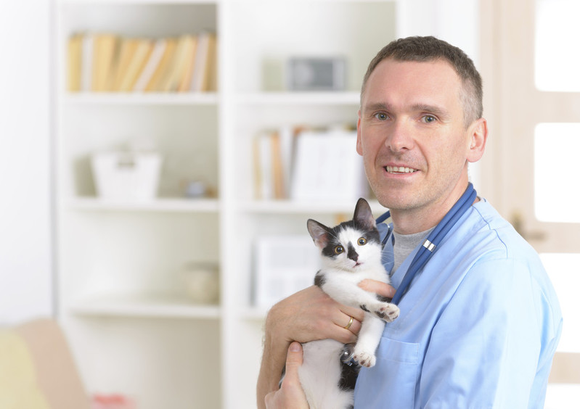DR SANDERS

Leroy walked into Dr. Sanders front door when he was moving into a new house. After searching for weeks for Leroy's guardians, he decided to make Leroy a part of his pet family, and now has three cats.